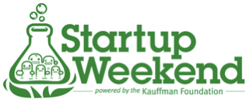

We are currently organizing a Startup Weekend to take place on November 9 at the METS Center. Startup Weekend is a non-profit based in Seattle, Washington that organizes 54-hour events in cities around the world, all of which help educate, support, and empower people to become entrepreneurs. Feel free to check out this video for more information http://vimeo.com/32424882.
We’d love to get the community more involved so we’re spreading the word and we’d love for Hive13 to participate. I have created a discount for your members as well as a quick blurb about the weekend to make it easy for you. The discount code is LAUNCHPAD and that will allow them to register for the price of only $40--you can feel free to include the following in your message:

Startup Weekend is back in Cincinnati – November 9, 2012! If you're not familiar, Startup Weekend is a 54-hour event where developers, designers and business development folks come together to pitch an idea and launch a business, all in one weekend. It is a great opportunity to test startup ideas, meet potential co-founders, build the community in Cincinnati and launch your next startup! For more information and to register for the event visit: cincinnati.startupweekend.org
Thanks in advance for the help! Please don't hesitate to reach out if you have any questions.

Cheers,
Team Cincinnati
cincinnati@startupweekend.org

